* **Name of the Seminar:** Seminar on Women Empowerment and Legal Awareness
* **Resource Persons:** 
  + Ms. Priyanka Malitha, Dy. SP. IUCAW (Investigative Units for Crime Against Women), Krishnangar PD.
  + Mr. Sanjeet Ambastha, Secretary District Level Service Authority, Nadia
* **Date of the Activity:** 22.03.2022
* **No of Participants:** 132
* **Organizing Department:** Career Counseling Cell, Chakdaha College.
* **Outcome:** 
  + Students learned about the legal frameworks in place to protect women's rights, including laws related to gender-based violence, harassment, equal pay, and workplace rights.
  + The seminar empowers women with information about their legal rights and the resources available to seek legal recourse in case of violation or discrimination.

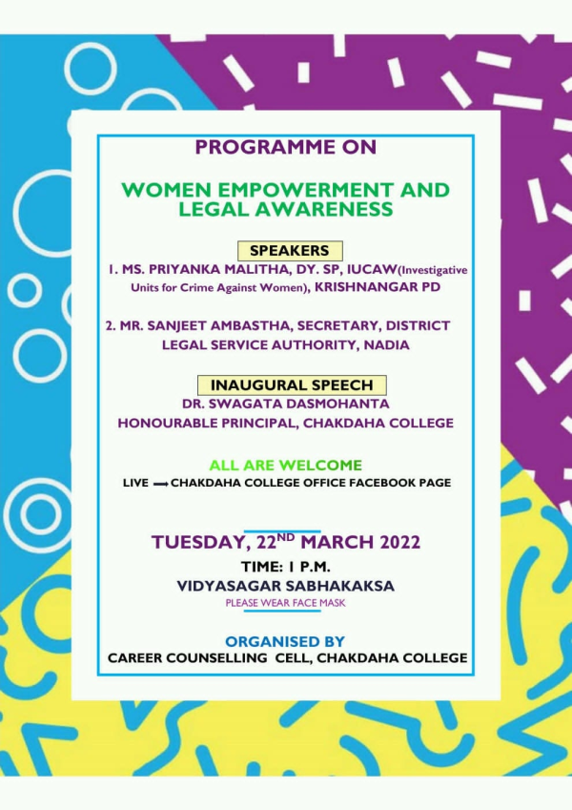

**Photograph:**

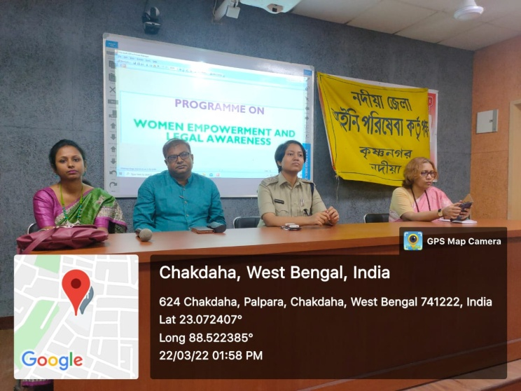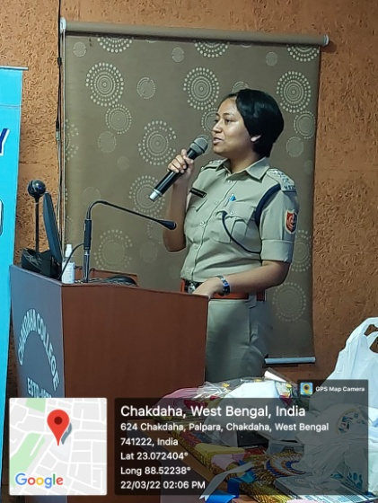

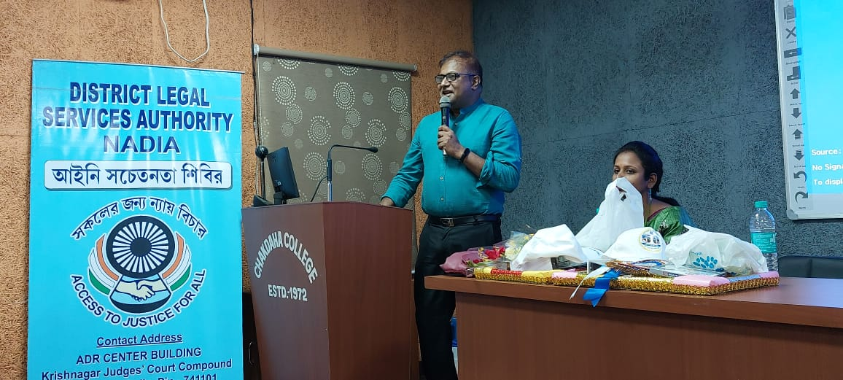

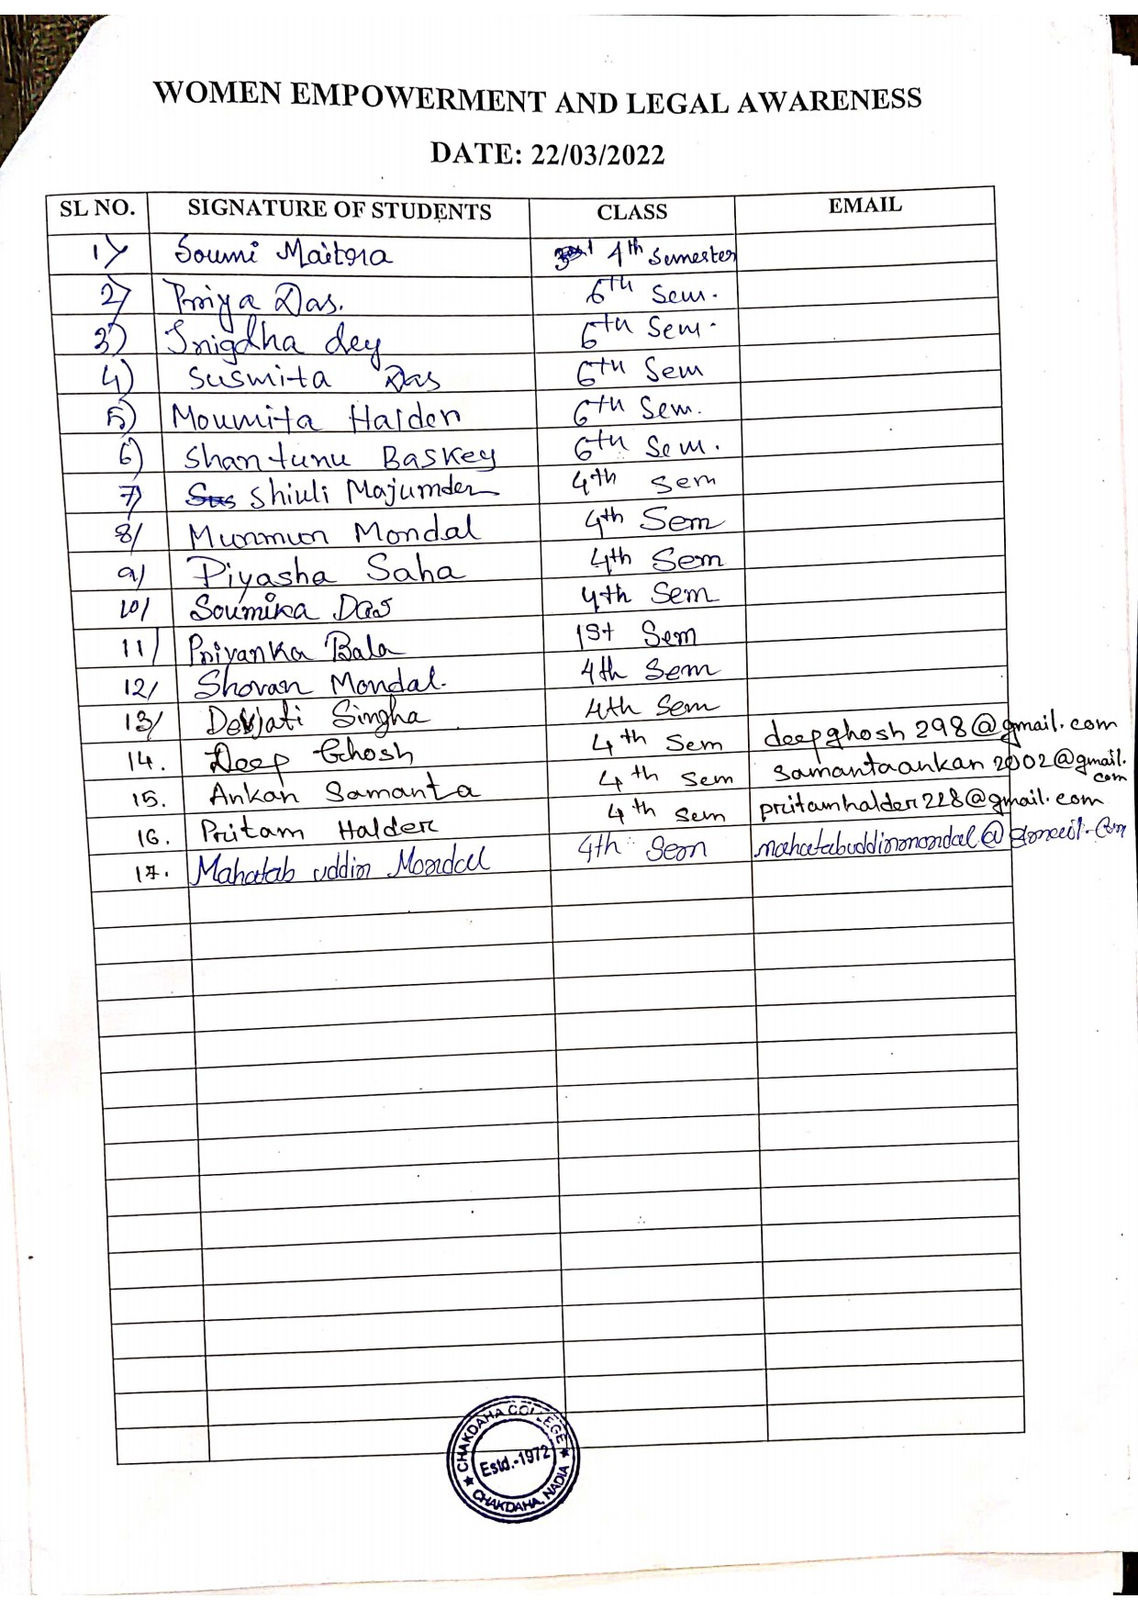**Attendance:**

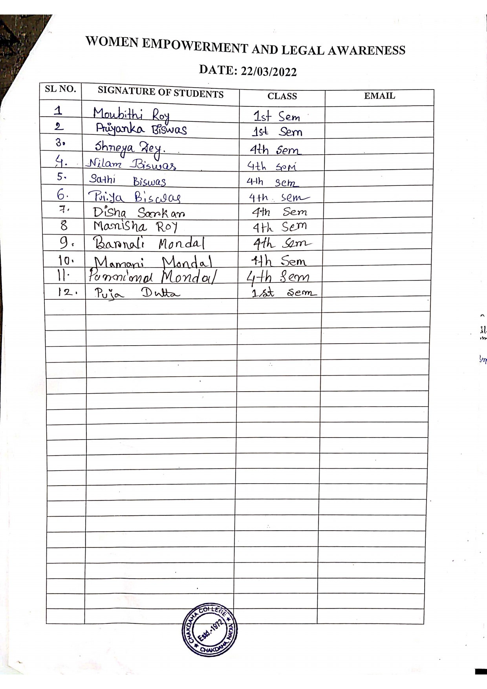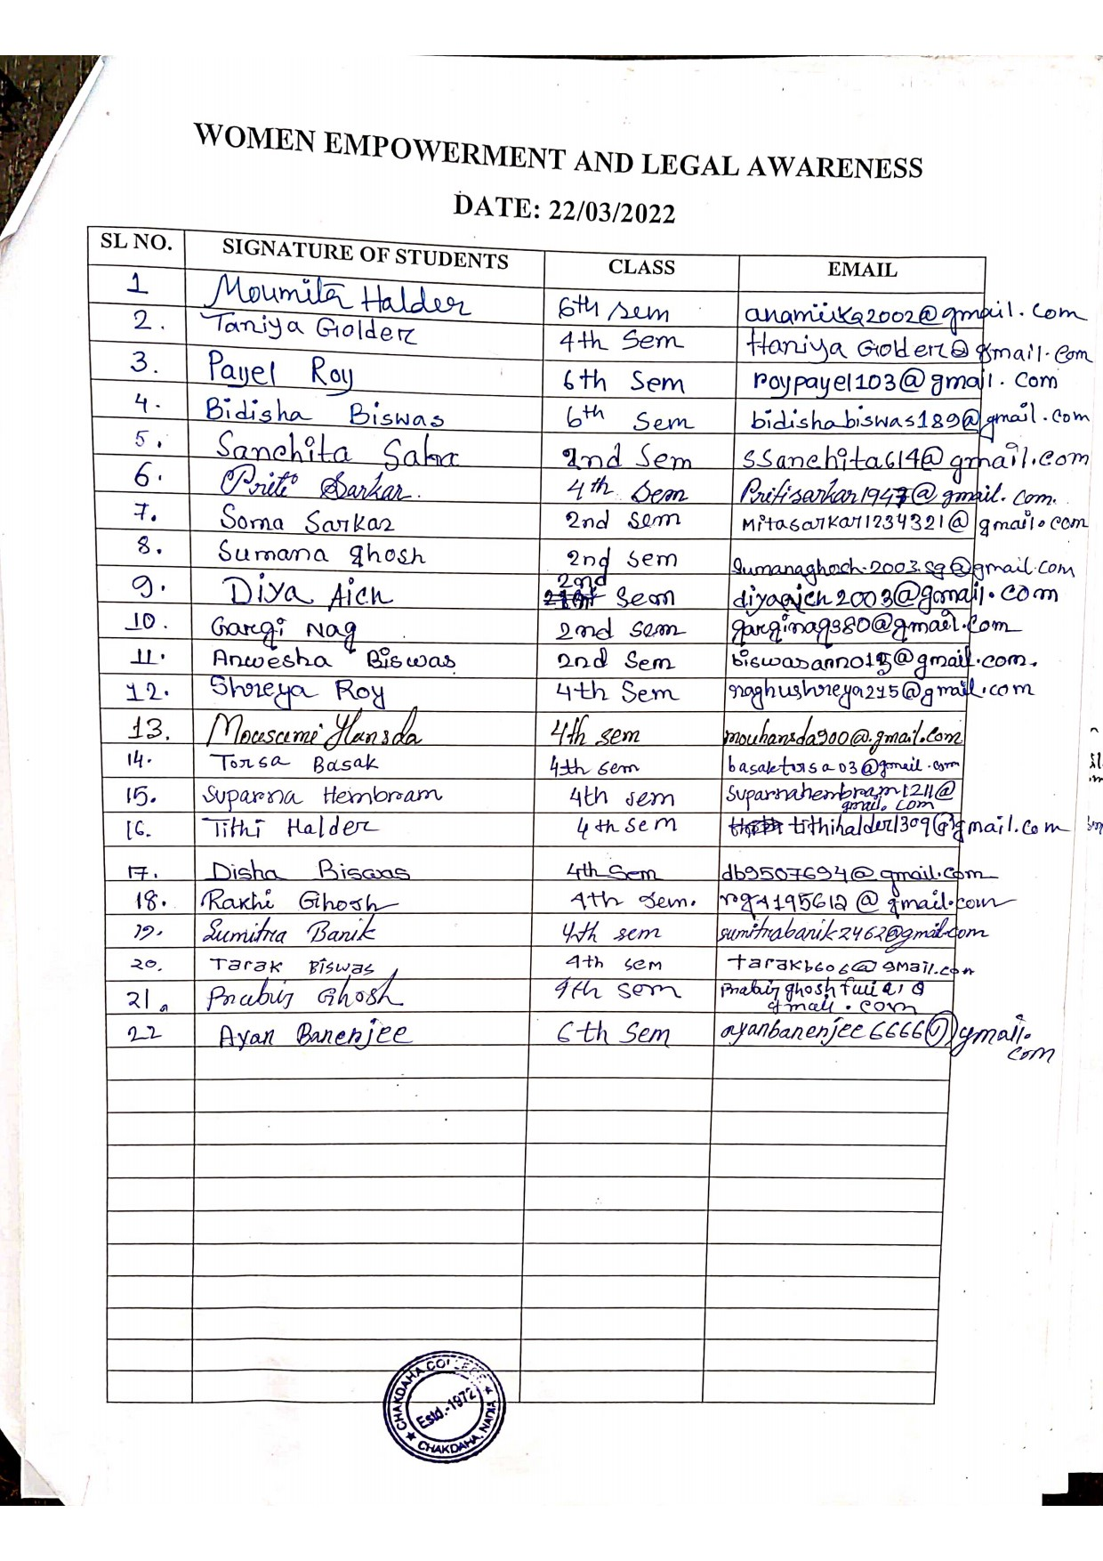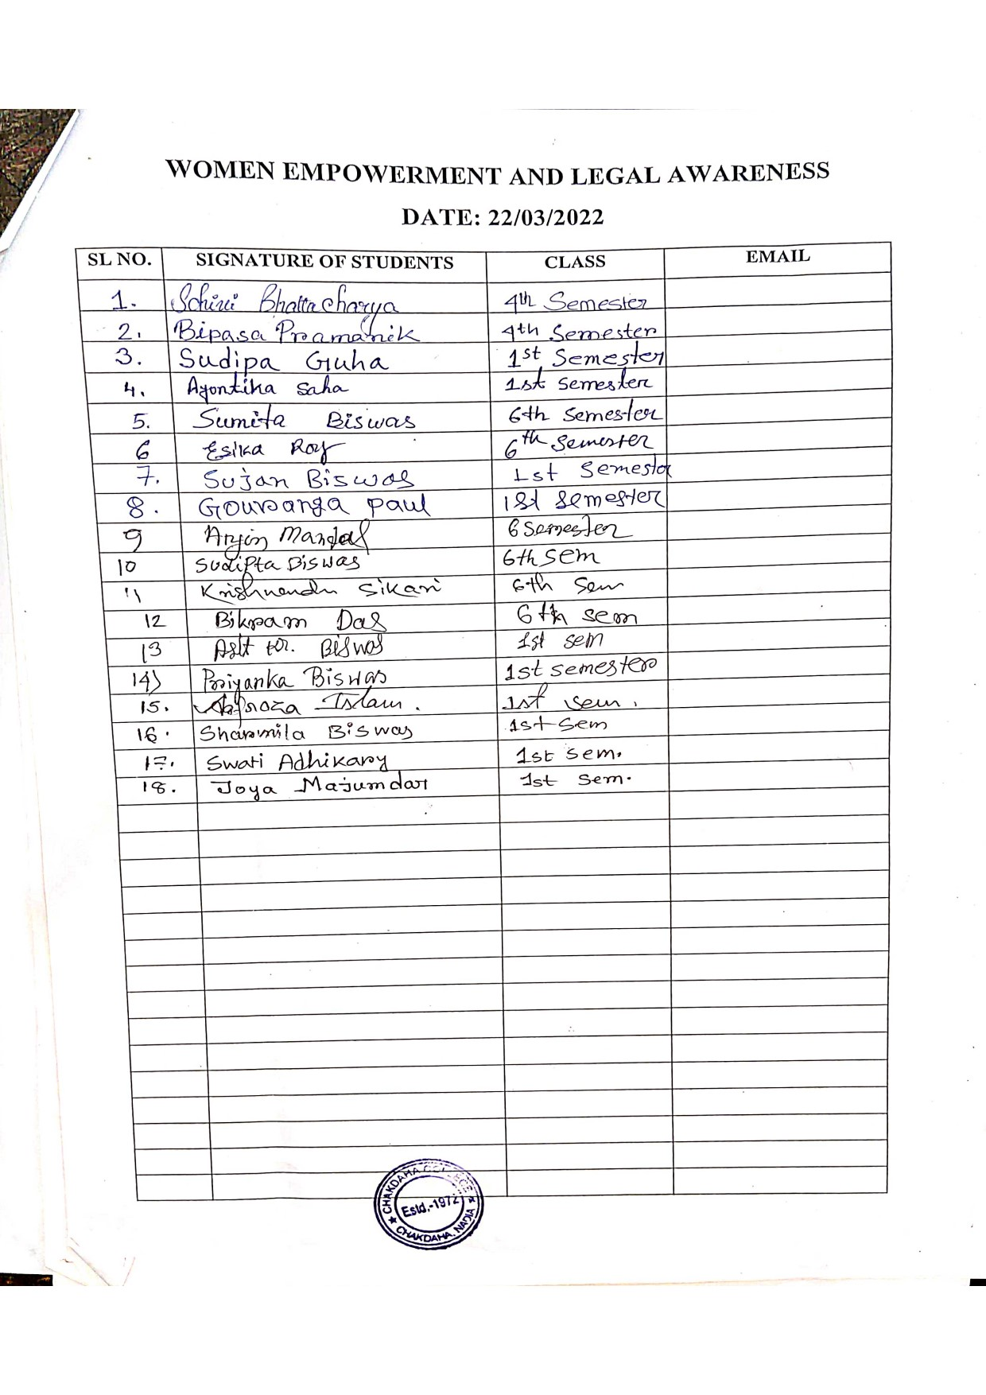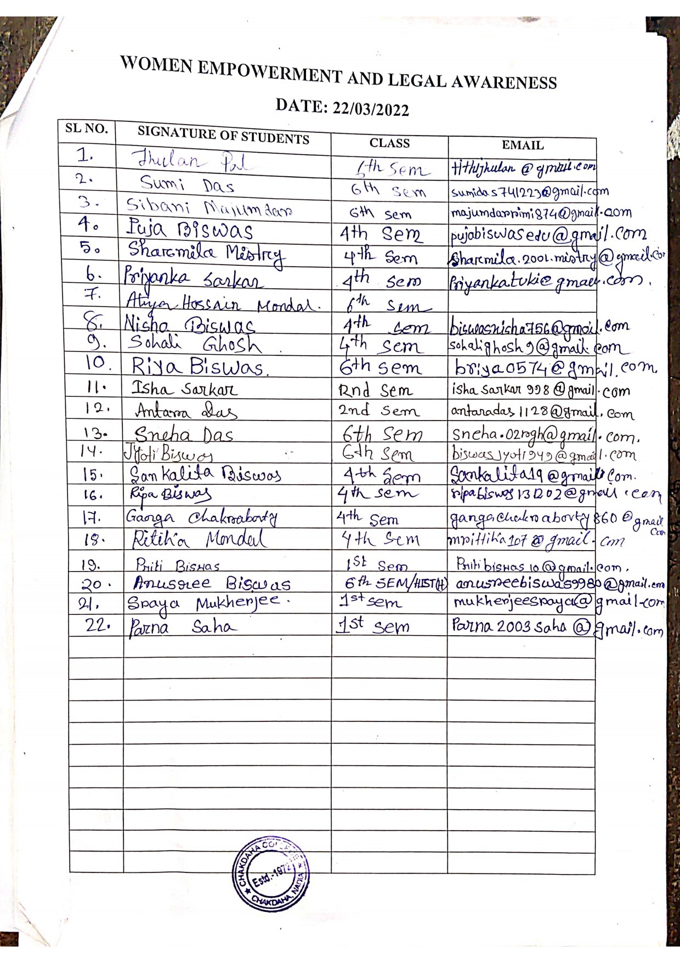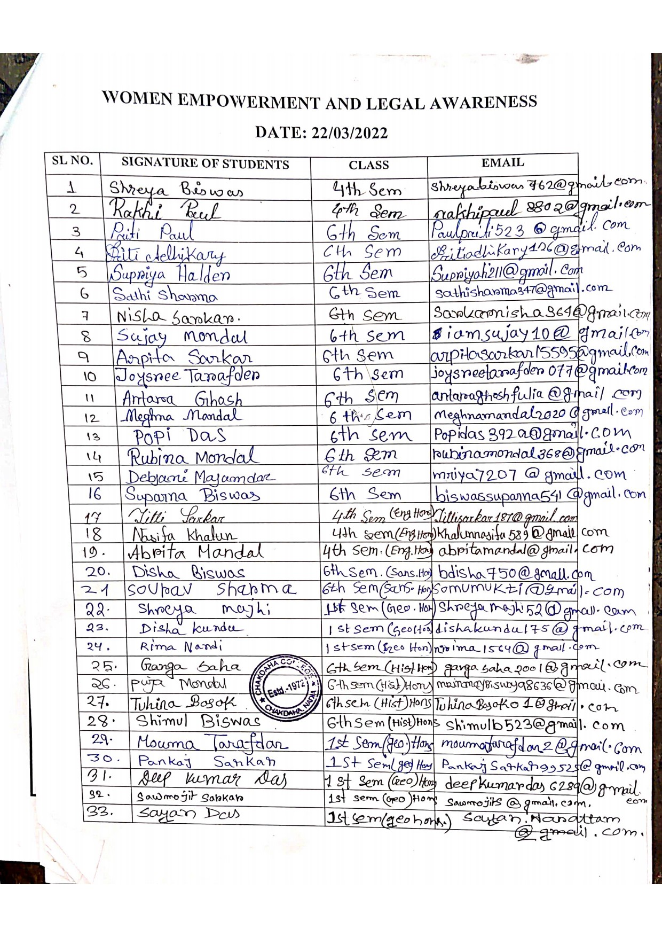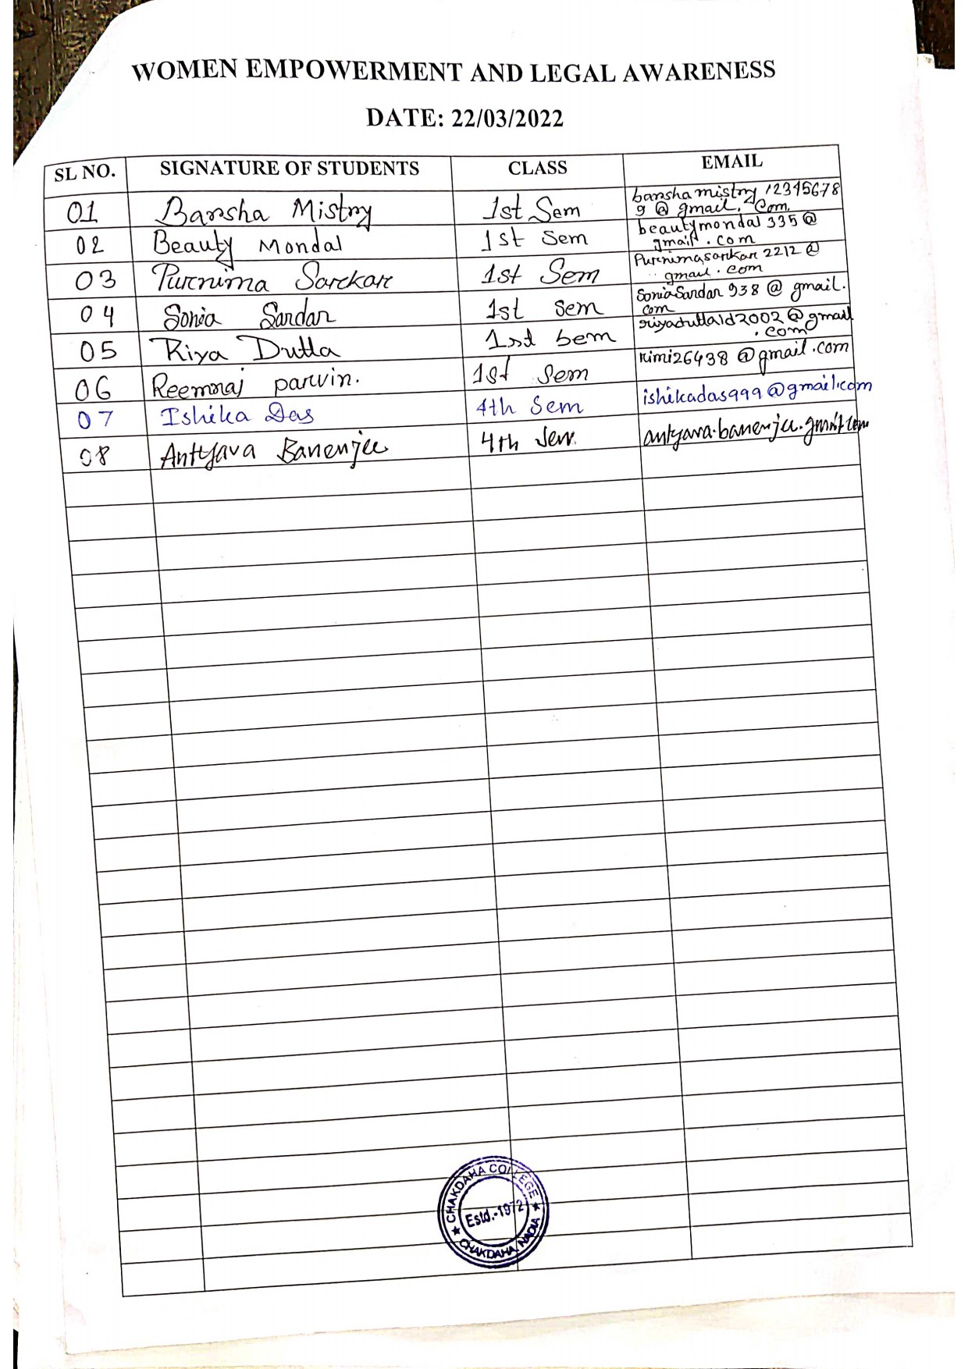

***Relevant Web Link:***

<https://www.facebook.com/chakdahacollegeoffice/photos/a.116093593584612/477159284144706>